All the steps in all the labs need to be run in the us-west-2(Oregon) region.

Lab – Prerequisite

- Download all files in one folder attached with this lab guide.
- Login to the console and go to S3 console.
- Create a S3 bucket in the us-west-2(Oregon) region.
- Create a folder called ‘data’ under the created S3 bucket.
- Create transaction folder under data and upload .gz files provided as part of lab guide.
- Create a folder called ‘store_reference’ under the ‘data’ folder in the S3 bucket
- Upload the ‘store_reference.json’ file provided as part of the lab guide pack to the ‘store_reference’ folder on S3.

This is for a sample bucket, you will have your own unique bucket in the region.

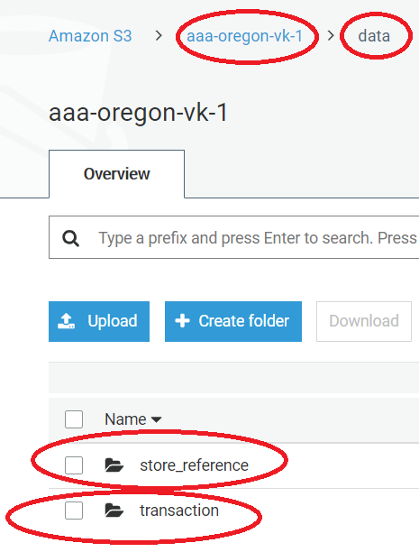

Lab – Data cataloging using AWS Glue

- Go to console and navigate to IAM and then to Roles
- Click on “Create Role”
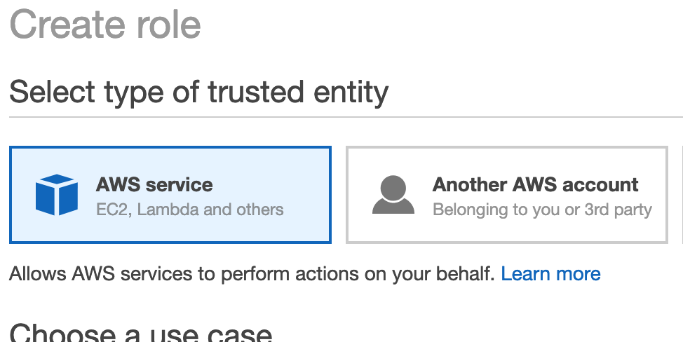

- Under AWS Service, select Glue as the service that will use this role and click “Next Permissions”

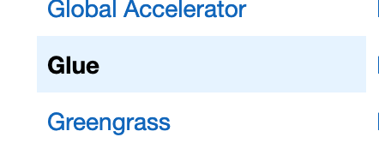
- On the next screen – attach 2 policies to the role – AmazonS3FullAccess and AWSGlueServiceRole. Click “Next Tag” and “Next Review”

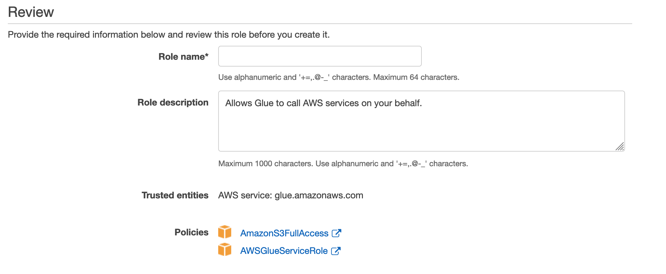
- On the final screen, provide a name to the role – something like AWSGlueServiceRole and create the role.
- Go to main console and navigate to the AWS Glue console.
- Click on “Databases” on left pane under Data Catalog.
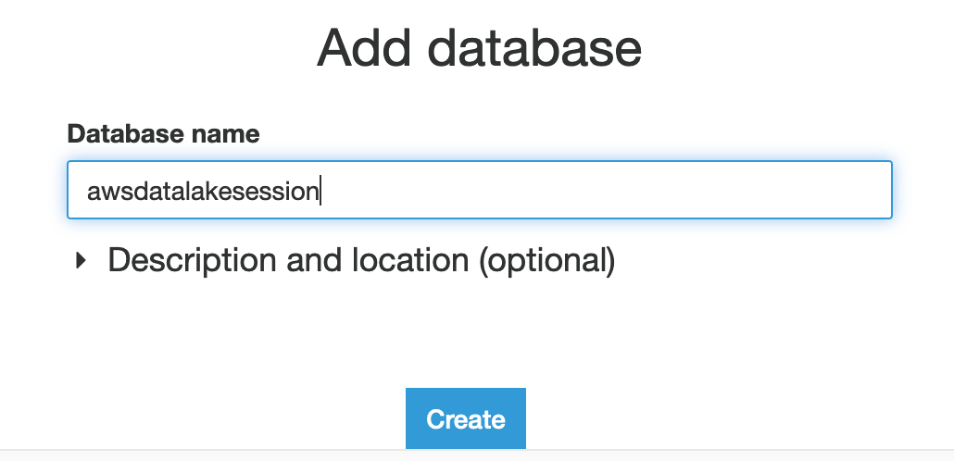

- Click on “Add Database” and create a database named “awsdatalakesession”
- Now, navigate to “Crawlers” and click on “Add crawler”
- Specify the crawler name as “awsdatalakesession”
- Leave the default values on the next screen – ‘Data Stores’
- On the next screen, specify data store as S3. Under the include path, specify the value as “s3://<your-bucket-name>/data/ where <your-bucket-name> is the S3 bucket you created in Lab prerequisite section.
- On the next screen – “Add another data store”, select “No”
- On the next screen, click “Choose an existing IAM role” and specify the role that you created above(“AWSGlueServiceRole”).
- On the next screen, choose to run the crawler on-demand
- On the next screen choose the database “awsdatalakesession” and click “Next”
- Click “Finish”
- On the next screen select the crawler “awsdatalakesession” and run the crawler
- Once the crawler completes, navigate to “Tables” under databases”.
- Have a look at the tables created by the crawler. How many tables are added by the crawler? Navigate inside each table to see what information is held by the table definition. You should see the three tables as below
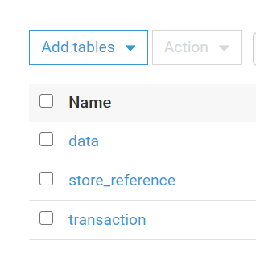

*******************************End of Lab***********************************

Lab – AWS Glue ETL Job

- Navigate to the AWS Glue console
- Under “Jobs”, click “Add Job”
- Specify name of the Job as “awsdatalakesession”
- Under IAM Role, choose the role you created in Lab 2(“AWSGlueServiceRole”)
- For Job Type – Choose Spark

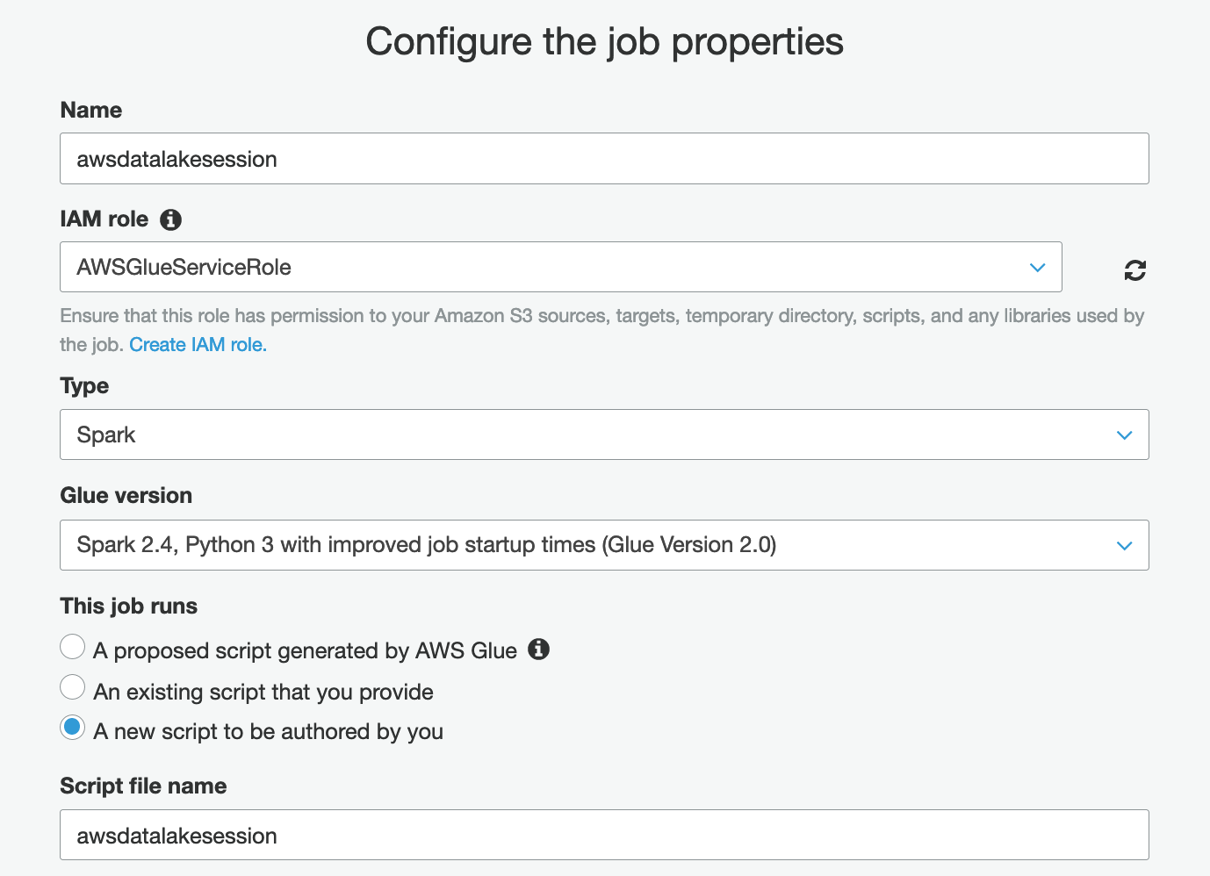

- For Glue Version – Choose Spark 2.4, Python 3 with improved job startup times (Glue Version 2.0).
- Under “This job runs”, specify “A new script to be authored by you”

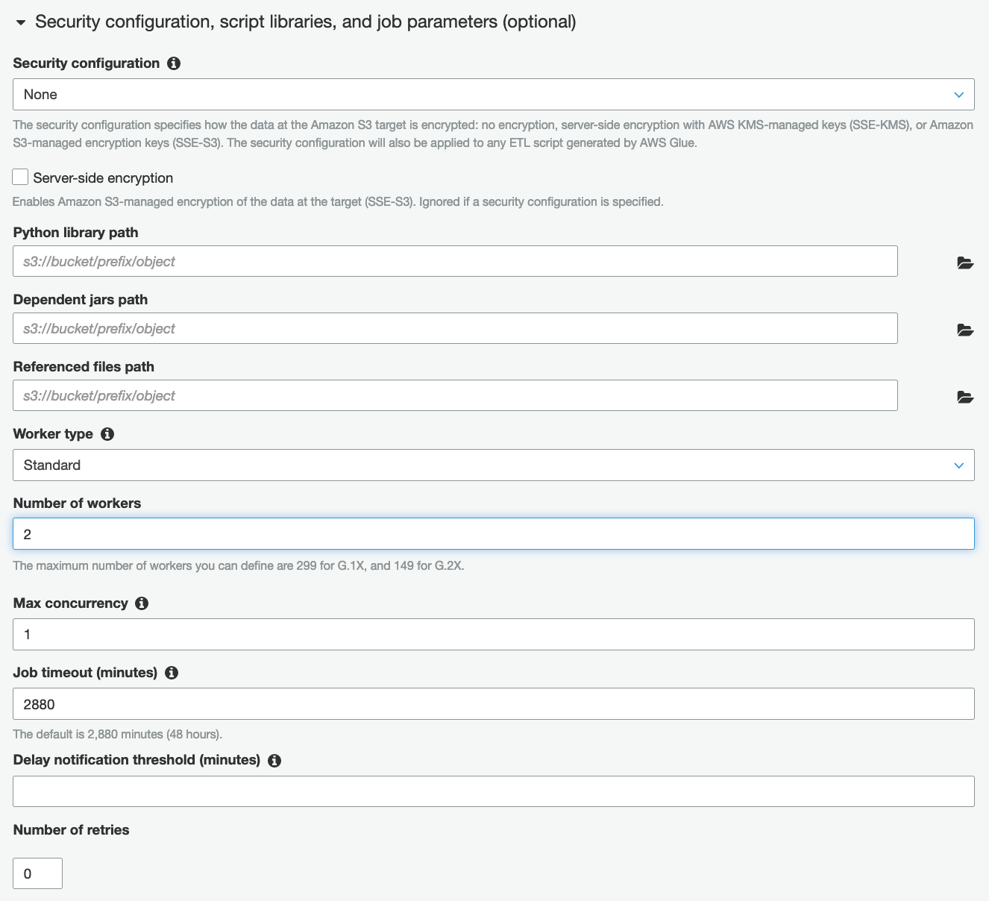
- Under “Security configuration, script libraries, and job parameters (optional)”, select worker type “standard” and set the “Number of workers” to 2.
- Leave the other values at default values and click “Next”
- On the “connections” screen, choose “Next”
- On the next screen, choose “Save job and edit script”

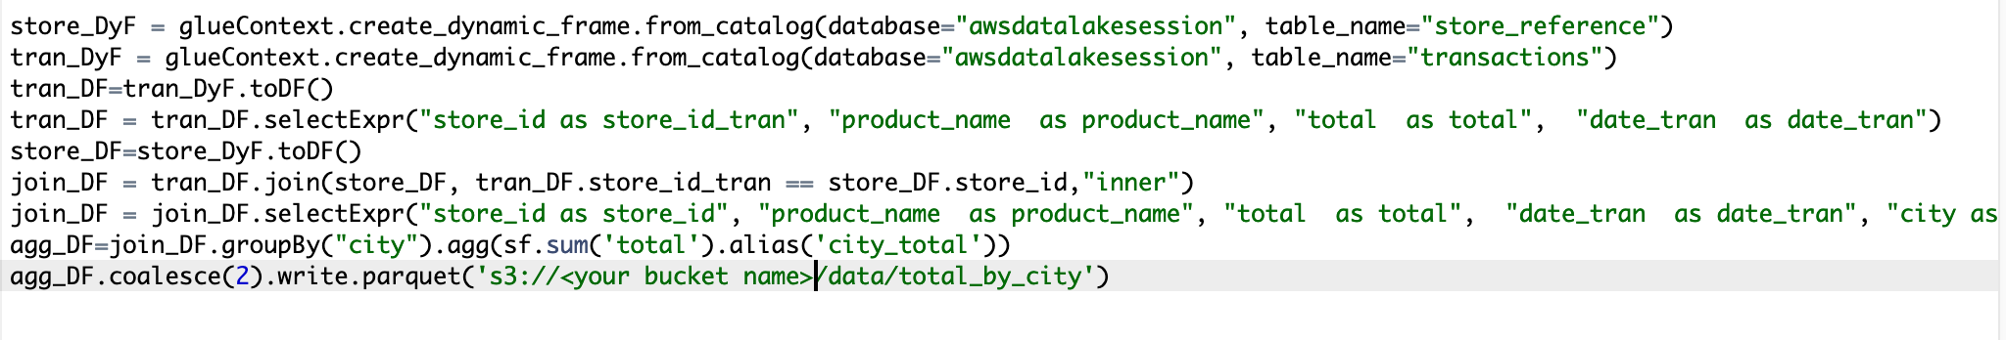
- Copy the script from the “Glue Job.txt” file in your lab guide zip file and replace the autogenerated script on the console with the code from the text file. Change the bucket name (<your bucket name>) to what you created in Lab prerequisite. Save the job and then run the job.
- Once the job completes successfully, navigate to the S3 bucket and see if a new ‘total_by_city’ folder has been created under the ‘data’ folder in the S3 bucket.
- Click the parquet file Select From. Check the contents inside the file. Select “Parquet” as file format, and click preview.
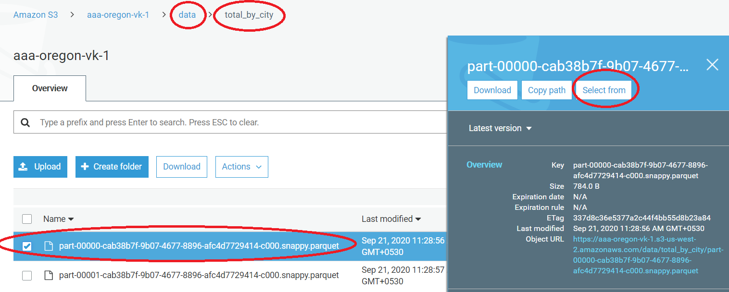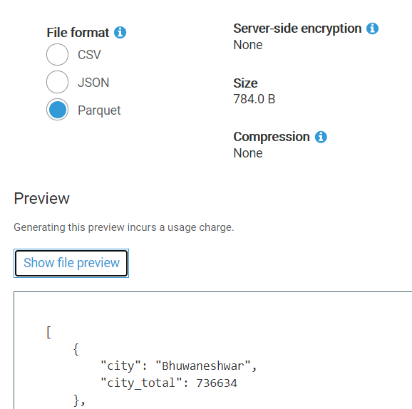

Lab – AWS Glue workflow

- Click workflow under ETL option from left pan and add a new workflow.
- Give name awsgluewf.

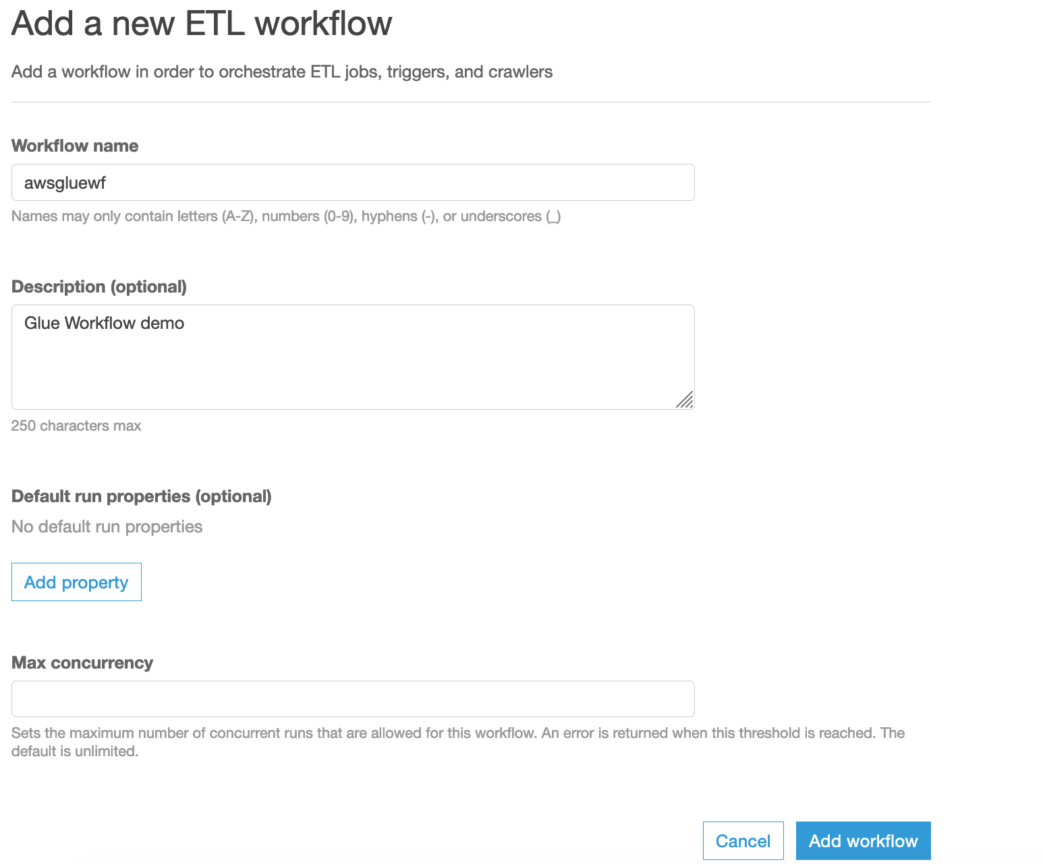
- Click “Add workflow” button.
- Select awsgluewf and click button “Add Trigger”
- In pop window select “Add new tab”

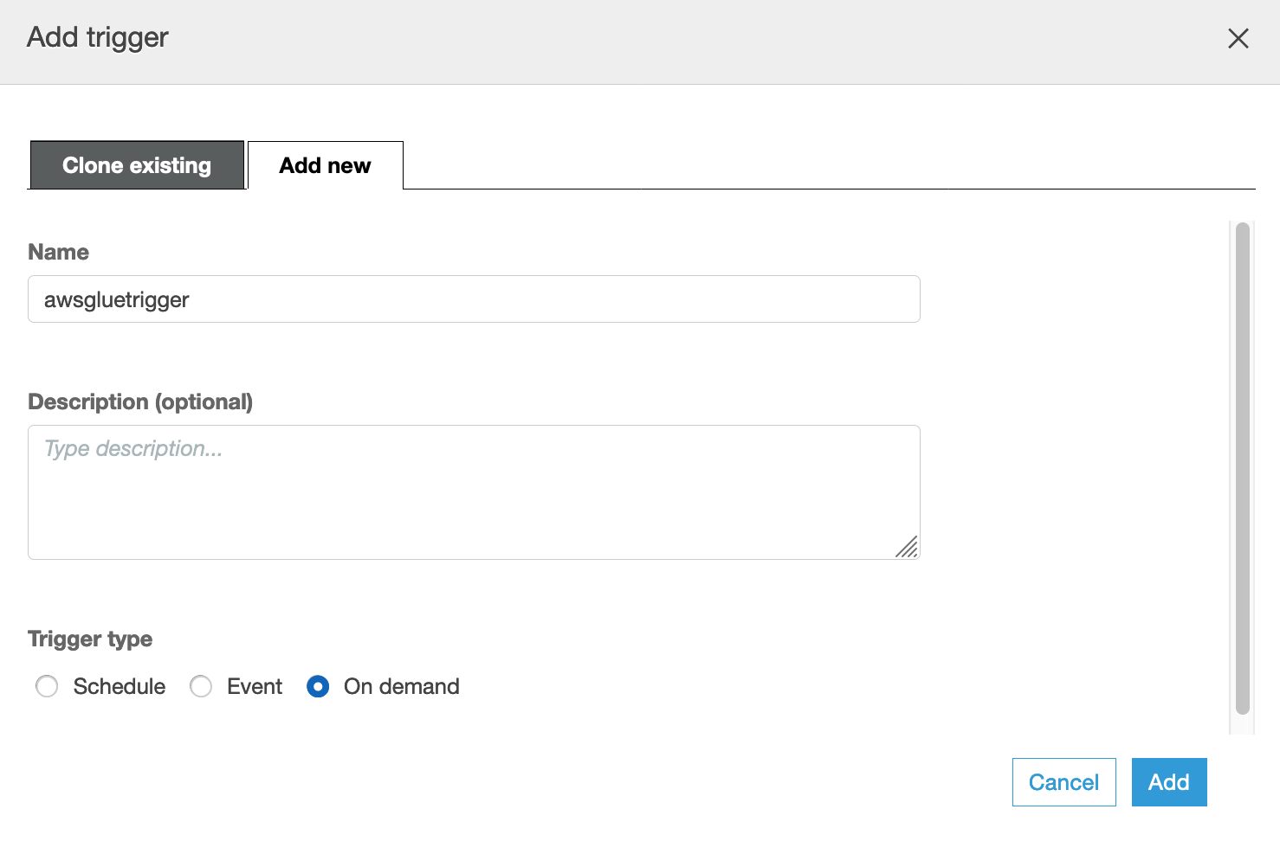
- Give trigger name awsgluetrigger and select “on demand” option to run the trigger.
- Click “Add” button.
- Click “Add Node” icon and select the crawler tab in popup window.

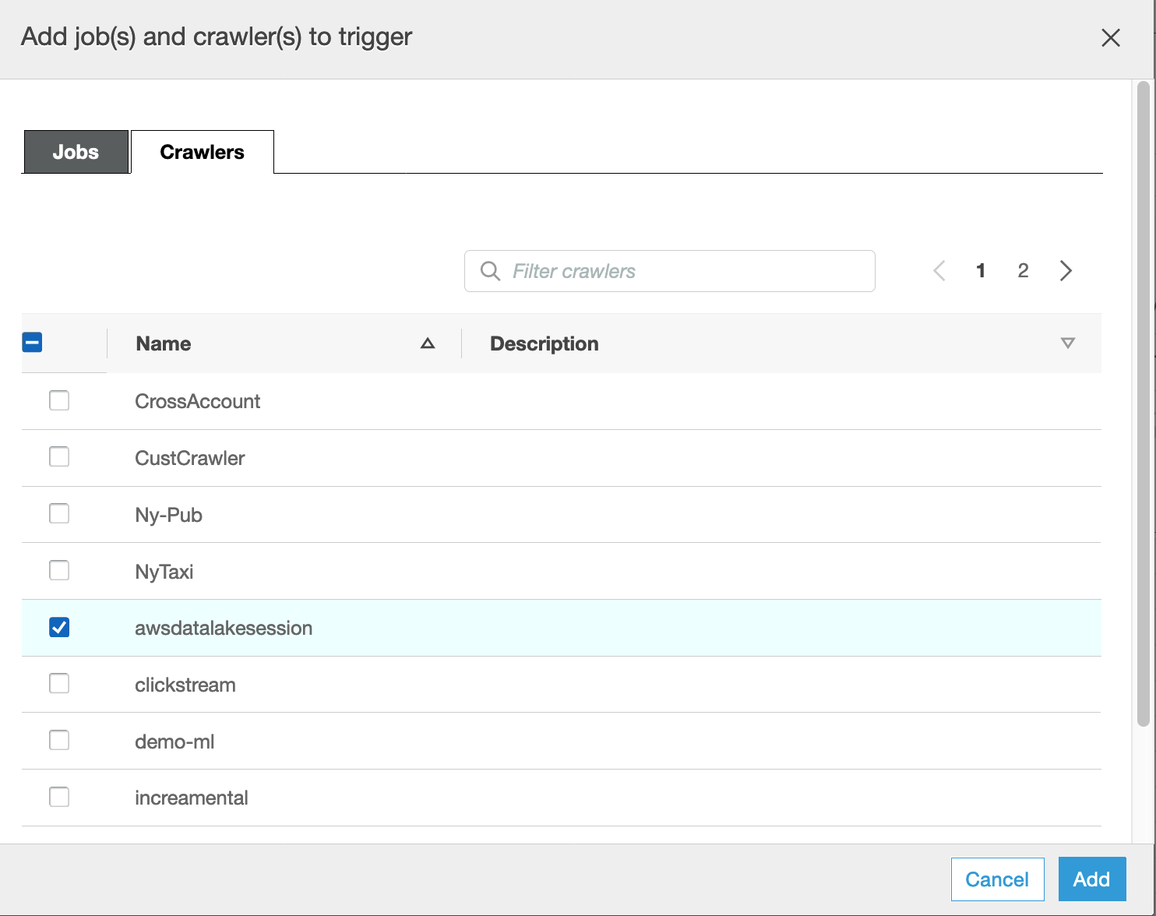

- Choose crawler name awsdatalakesession which you have created in previous lab and click “Add button”
- Click “awsdatalakession” icon and it will show you the trigger.

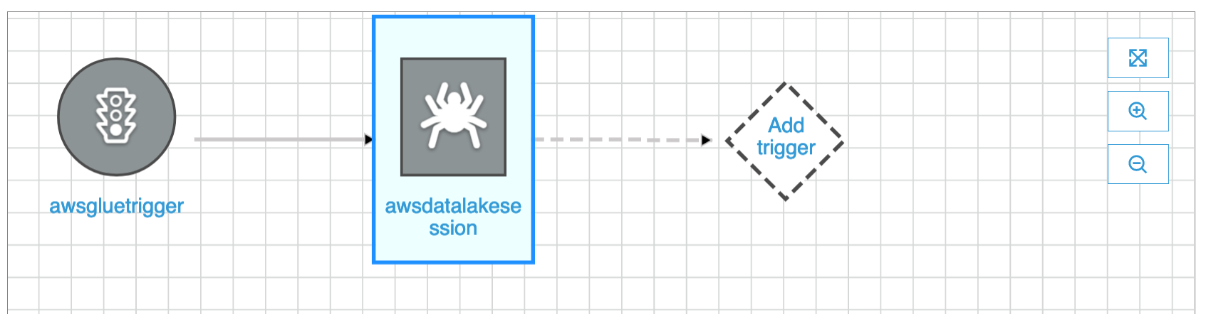
- Click trigger and one popup window will come. Give the trigger name CrawlComplete and click “Add” button.

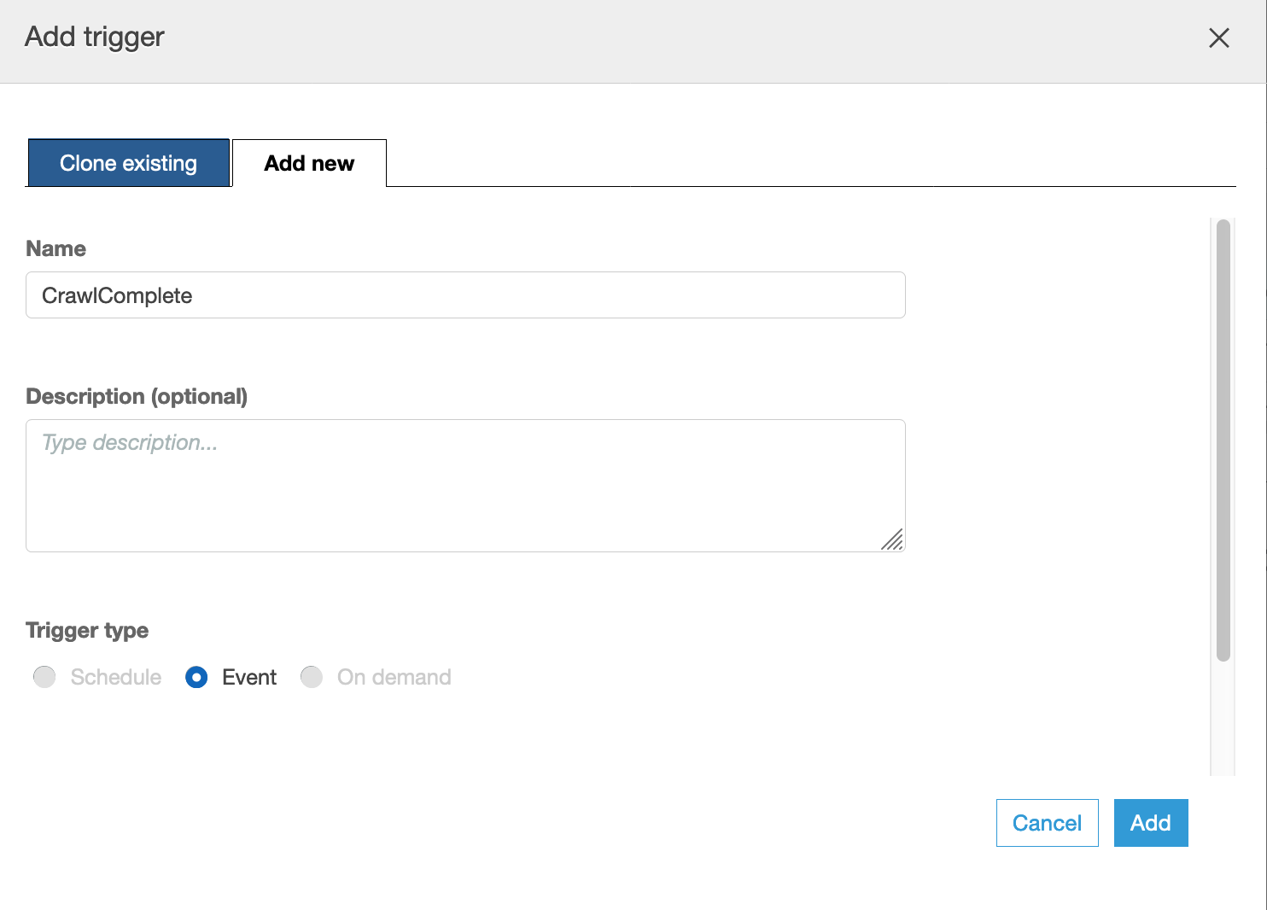
- Select Add node icon and then one popup window will come.
- Select job tab from that windown and select the job awsdatalakessession job which you have created in previous lab and the click “Add button”. Your screen look like following.

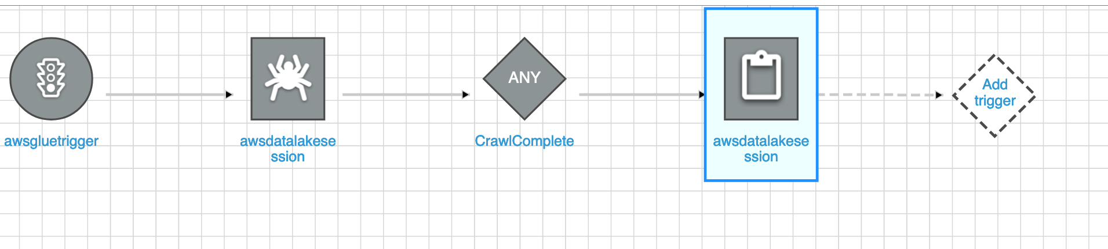

- Go to Databases section and select the database awsdatalakesession which you have created during catalog lab.
- Click the “Tables in awsdatalakesession” link

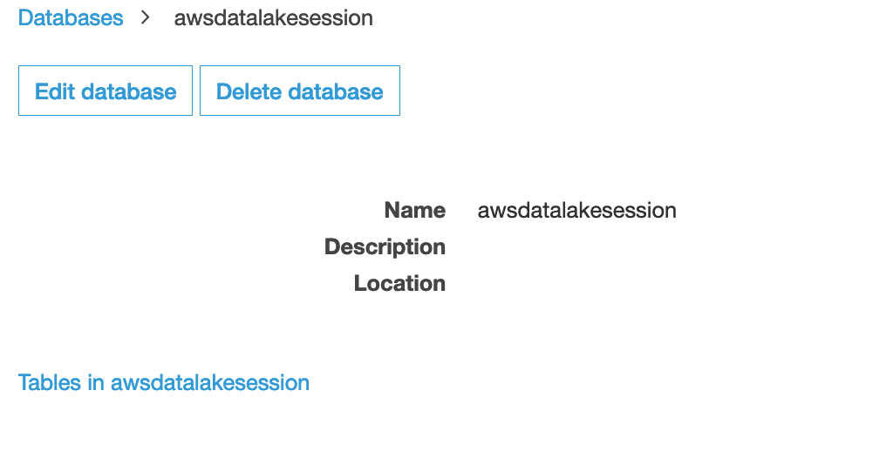
- Select the table transactions and then click “Action” button.
- Select delete table option to delete the transactions table.
- Go to the job and select the awsdatalakesession job and then click the “script” tab.
- Click “edit script” and change the line (before job.commit()) from s3://<your bucket name>/data/total_by_city' to s3:// ://<your bucket name>/data/total_by_city1' and press “save” button to save your change.
- Click “X” icon to close the job window.
- Under ETL, select the Workflow from left navigation pan.

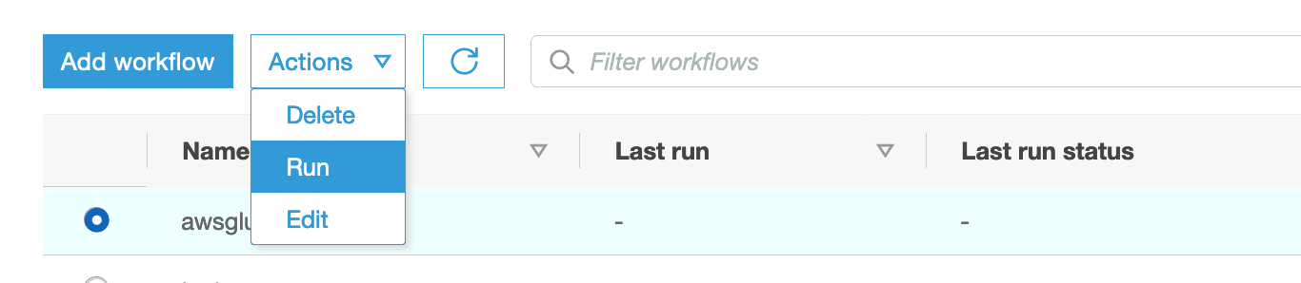

- Select the awsgluewf and then click “Action” button press “Run”.
- You can go to the crawler section and check the awsdatalakesession crawler is running or not.
- When crawler stops, check the tables under awsdatalakesession database. You can see transaction table has been created.
- Go to the jobs option under ETL and you can see your job is also in running status.

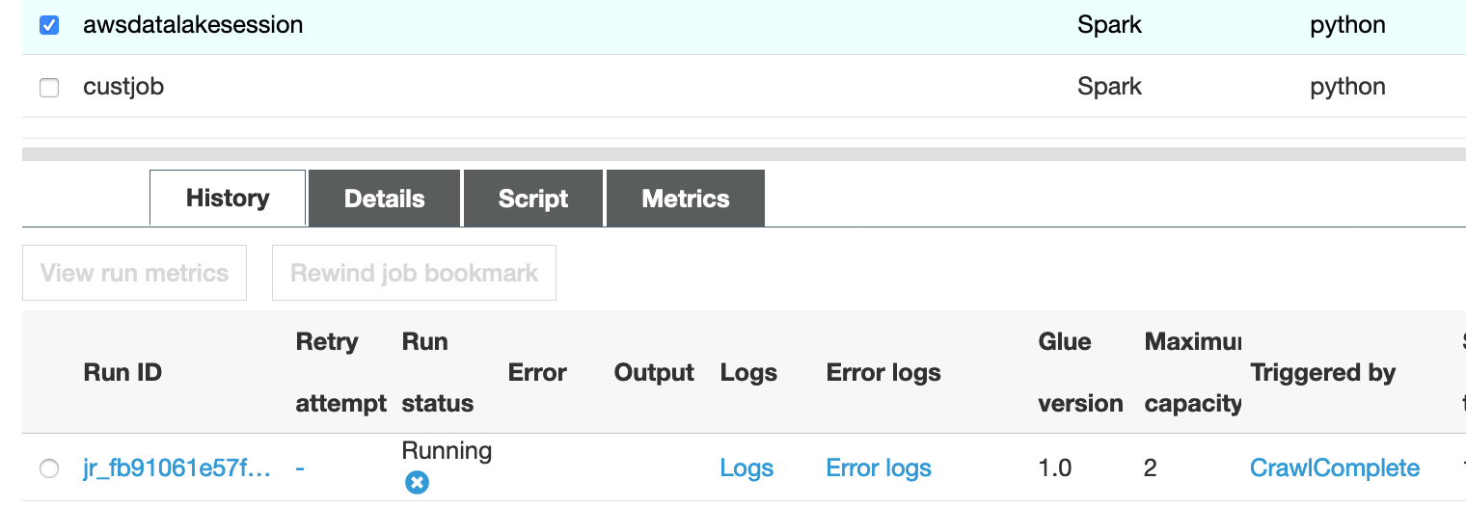

- Wait for job completion and when it will finish then go to s3 and check whether total_by_city_1 has been created or not under data folder.

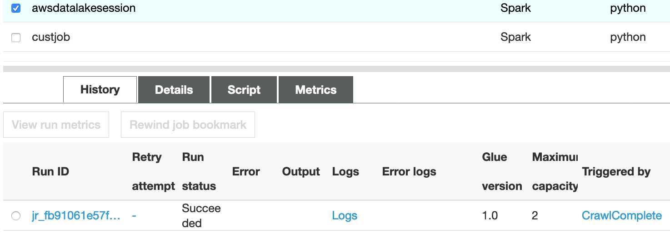

#####################End of Lab#######################

